**

Mohammad Ali Jinnah University

Chartered by Government of Sindh - Recognized by HEC

Assignment 5

**Subject**: Software Construction and Development (SCD)

**Section**: AM

**Teacher**: Muhammad Tauseef

**Muhamad Fahad** (FA19-BSSE-0014)

(FA19BSSE0014@maju.edu.pk)

Assignment 5

**Question: You have given System Specification of Online Shopping Cart and we need to illustrate the End User Requirements. Please illustrate each and every process with the involvement of the end users.**

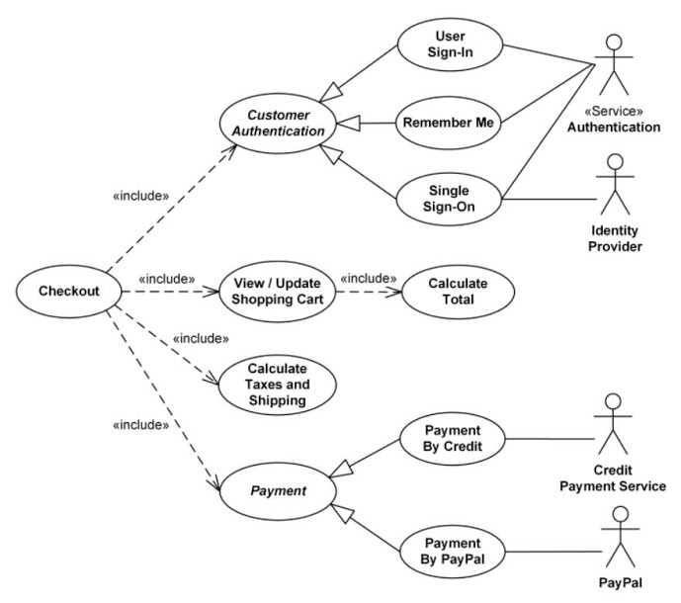

**Answer:**

The Requirement of the end user are followings:

* The user can sign in, can also use remember me and can single sign on.
* The user can pay through credit or PayPal.
* The user can View and Update shopping cart or calculate the total.
* The user can calculate Taxes and shipping.